

**The University of Azad Jammu and Kashmir,**

**Muzaffarabad**

|  |  |
| --- | --- |
| Name | Kamal Ali Akmal |
| Course Name | Operating System |
| Submitted to | Engr. Sidra Rafique |
| Semester | 3rd |
| Session | 2024-2028 |
| Roll No | 2024-SE-38 |
| Lab No | 03 |
| Submission date | 31 October 2025 |

**Virtual Machine**

A virtual machine (VM) is a software-based computer that behaves like a physical computer but is created from a pool of hardware resources. It lets you run another operating system, like Windows or Linux, without needing a separate physical device.

For example, you can run Windows on a Mac or test software safely in a separate environment.

**How it works**

A hypervisor (a Virtual Machine Monitor) manages the creation and execution of VMs. There are two types:

* **Bare-metal hypervisor**

Runs directly on the host's hardware (e.g., VMware Esi, Microsoft Hyper-V).

* **Hosted hypervisor**

Runs on an existing OS (e.g., VMware Workstation, Oracle VirtualBox).

**Benefits**

Virtual Machines have many benefits, including

1. **Cost savings**

VMs can reduce ongoing support and maintenance costs.

1. **Flexibility**

Test different operating systems or software without affecting your main system.

1. **Disaster recovery**

If the host crashes, VMs can be easily moved from one hypervisor to another.

1. **Security**

Use VMs to run risky software or isolate suspicious files safely.

1. **Isolation**

Each VM is separate, so problems in one won’t harm the others or the host machine.

**Step-by-step Installation of VMware**

Below are the detailed steps for installing VMware Workstation.

**Step 1.**

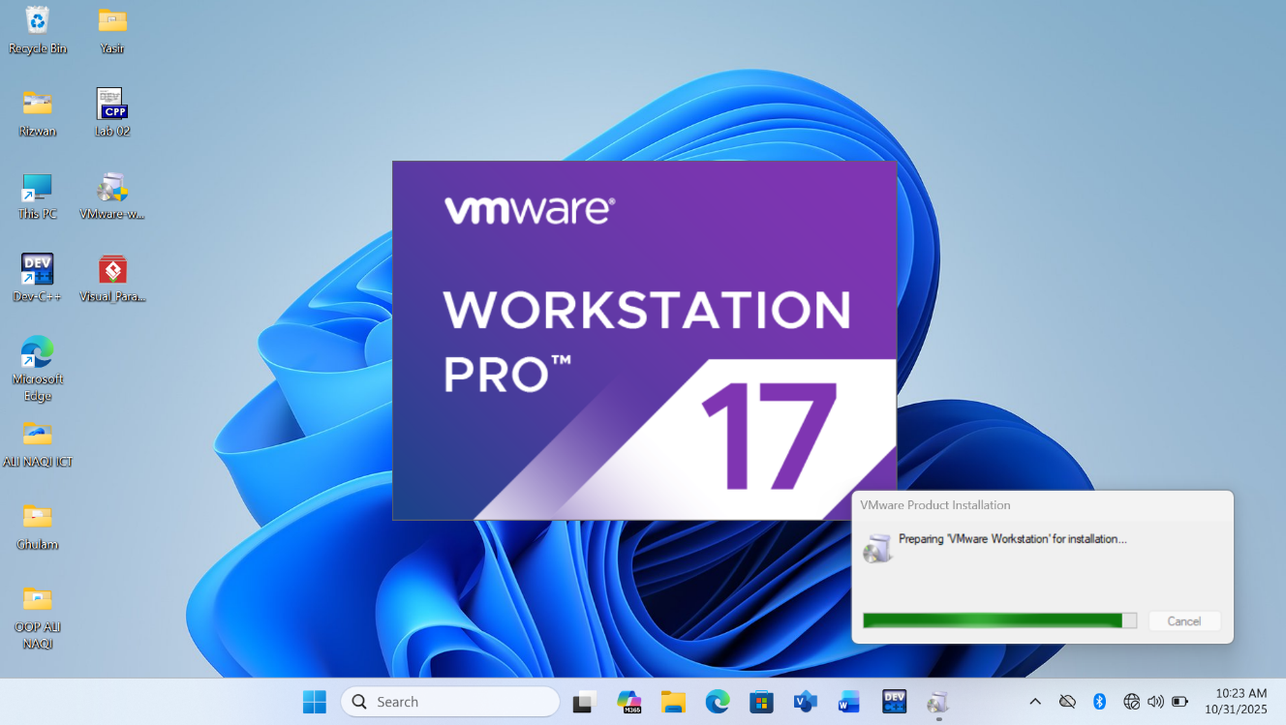

**Step 2.** Run the .exe to install VMware Workstation. A popup will appear.

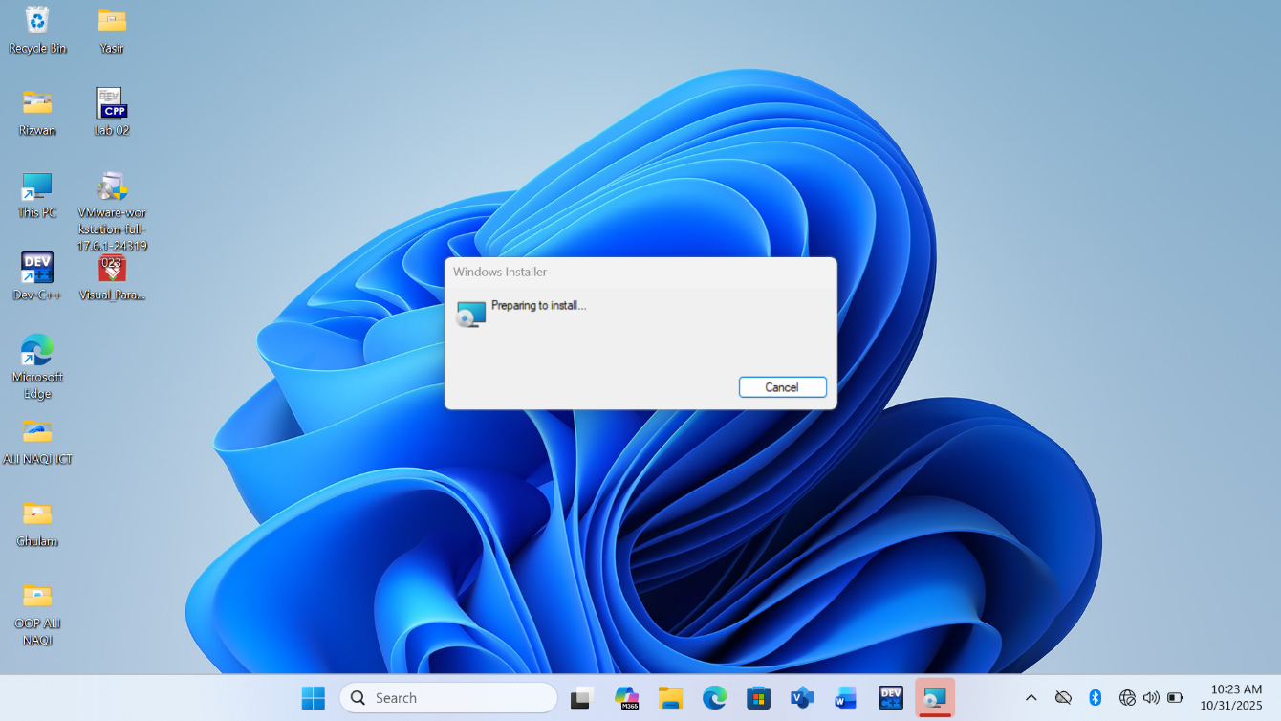

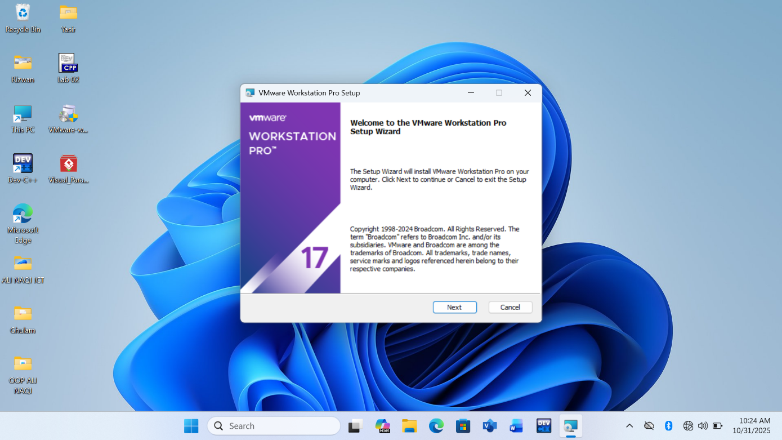**Step 3.** Once Initialization gets completed, click Next.

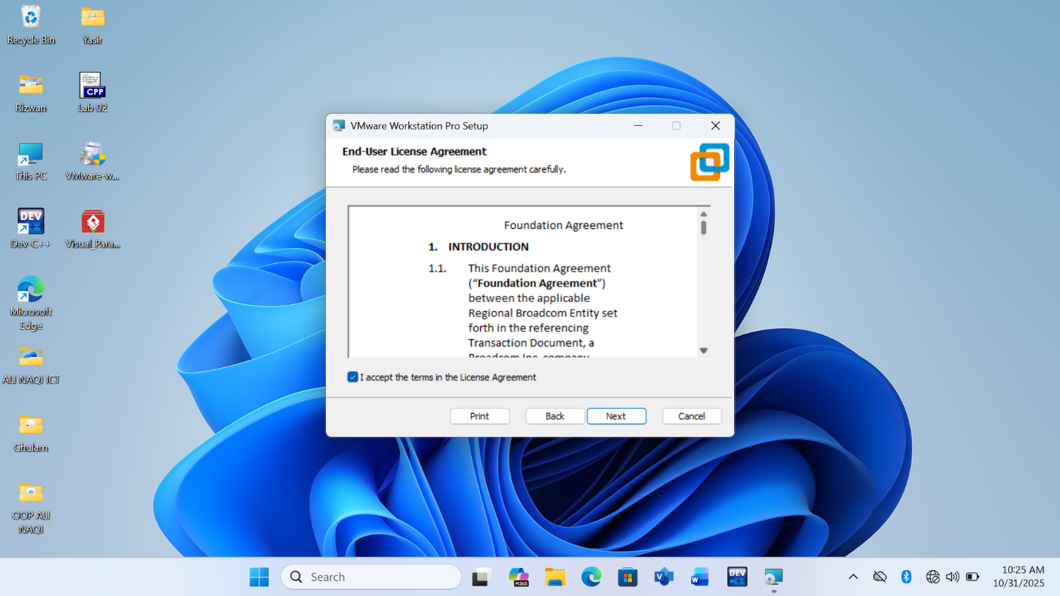**Step 4.** Accept the terms and click next

**Step 5.** On the next screen, it will ask for additional features; it is not mandatory to check this box. Click on Next

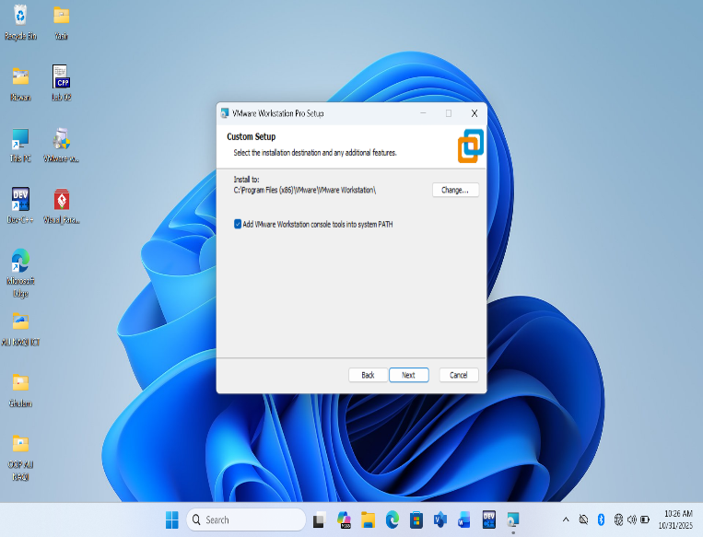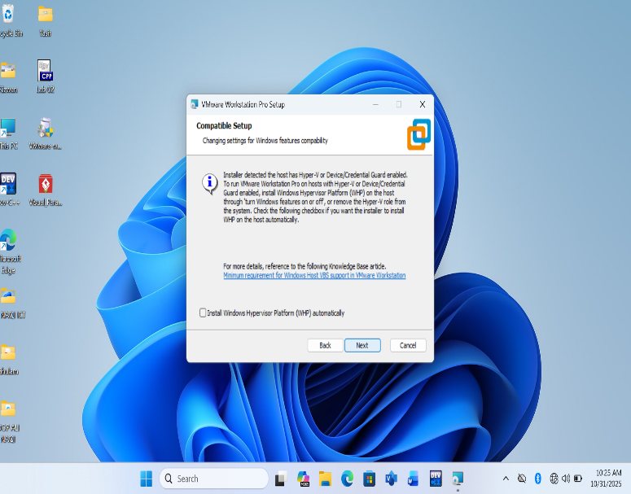

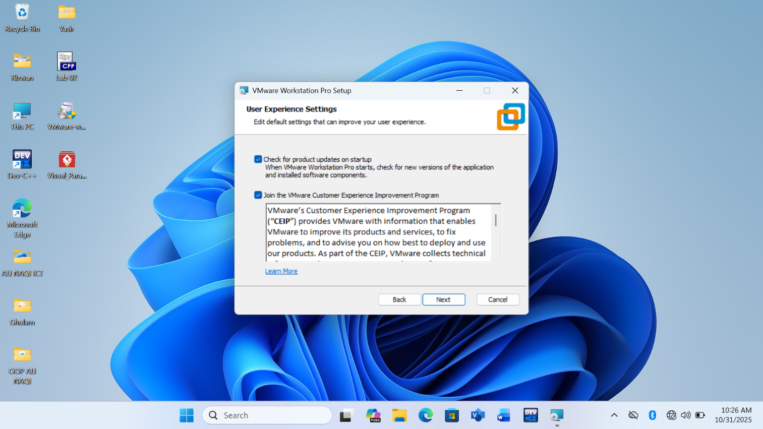**Step 6.** On the next screen, some checkboxes are populated; check them as per your requirement. Click on Next.

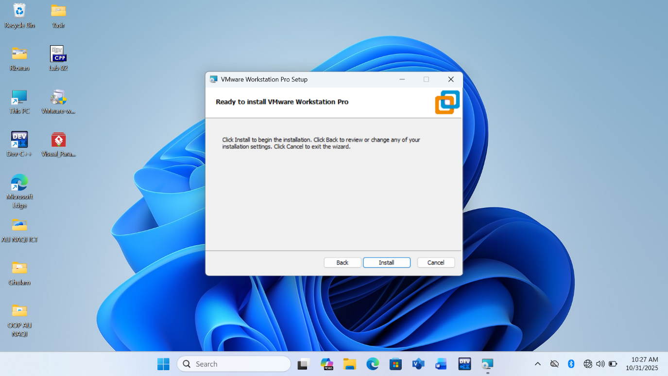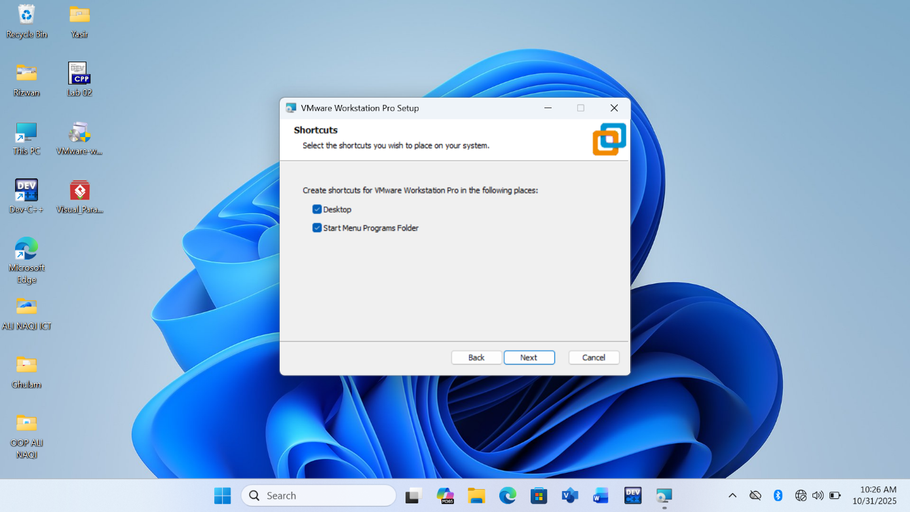**Step 7.**At this step, VMware Workstation is ready to install. Click on Install.

**Step 8.**At this step, you can see installation taking place. The installation will take some time; wait for it to be installed properly.

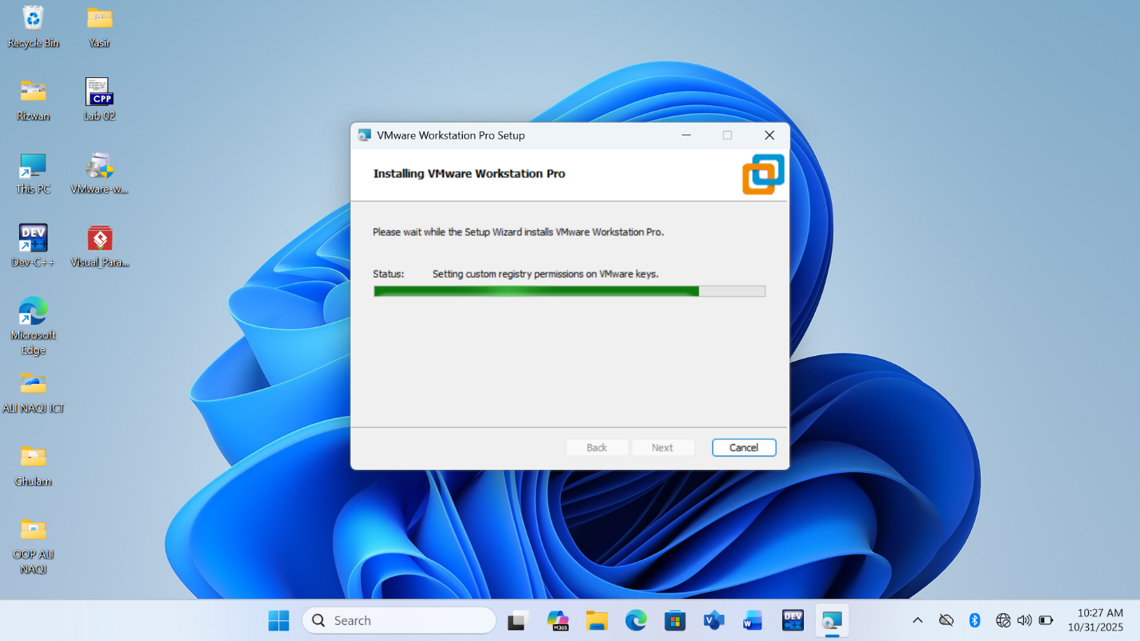

**Step 9.**Once the installation is completed, you will see the following dialogue box. Click on Finish. If you have purchased the product and have a license key, click on License to enter the key.

